CSLAB

ISEP - DEI - MESCC

Smart Lighting and Heating System

Group 7:

Carlos Rijo - 1101626

João Fernandes - 1221973

1. Introduction

In this document, we will discuss the technologies planned to be implemented in our project and the reasoning behind our choices. Our goal is to provide a clear and concise overview of the technologies we have selected and how they will be used to support the success of our project. We hope that this document will serve as a useful reference for all stakeholders and help everyone to understand the technological decisions that have been made.

To better understand our system, we need to describe what devices will need to communicate with each other and what data they will need to send to each other.

We made a high level diagram where we described our system which we can see below:

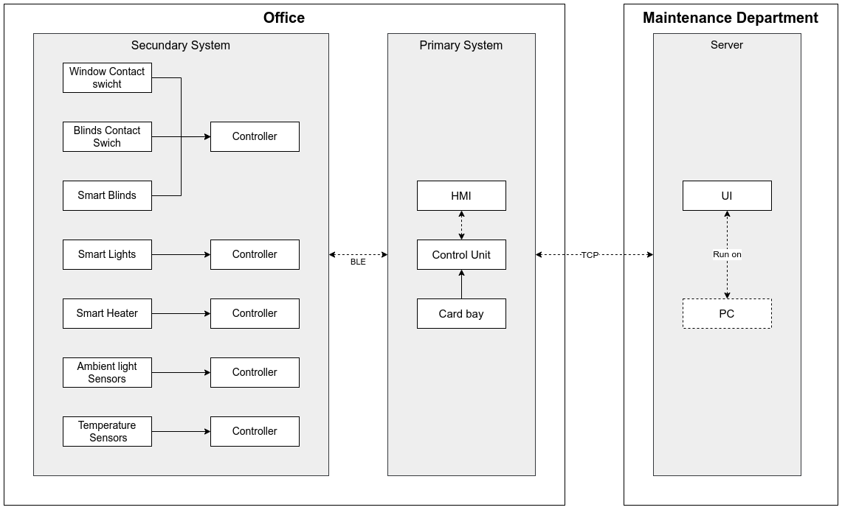

In this diagram we describe the project that we will implement, which is an automated climate and lighting control system. This system needs to be able to control three actuators: blinds, lights, and a heater for the user or maintenance team to set a desired temperature or luminosity for a target room.

1. Development

With this in mind, we understood that we need to monitor the temperature and the outside and inside ambient light of the room. For that we need to have at least two temperature sensors, at least four ambient light sensors, at least  ten contact switches in order to control the position of the blinds, a card bay and two contact switches for the window security control.

Since one of the requirements of our system is to have a redundancy factor, we will use a bundle of 2 sensors for each desired measuring, this means that we will have a bundle for the monitoring of the inside ambient light, one for the outside ambient light and one for the temperature.

For the readings we will check for malfunctions in each sensor and make an average. If one fails we will read just from one and send an malfunction error message. The only one where we don't have redundancy is the card bay sensor.

Since monitoring doesn't solve the problem at hand we will need actuators in order to manipulate the light and temperature to meet the set points defined. 

To control the temperature, we will use a smart heater, that can be controlled, to maintain a certain temperature in the room. The smart heater will be able to communicate with our primary system control unit to adjust its temperature as needed.

For controlling the ambient light in the room, we will use the blinds and lights. The blinds with an integrated motor that can be opened, closed or moved in steps (by using the contact switches) to allow more or less natural light into the room, and the lights can be turned on, off or dimmed to adjust the overall light level in the room. The ambient light sensors will be used to monitor the light levels and provide feedback to the control system to make adjustments as needed.

Regarding our lights we will use LED’s technology since they provide a better power consumption and will be easier to not only control but also implement.

An HMI (Human-Machine Interface) is a graphical interface that allows a user to interact with a machine, such as a computer or industrial control system, using input and output devices. In this case, the HMI will be used to control the light and temperature of an office using a touch screen. The touch screen will display various controls and information, such as current temperature and ambient light levels, as well as buttons or sliders for adjusting the light and temperature settings. The user can input commands through the touch screen, and the HMI will send these commands to the control unit that will communicate with the appropriate actuators (e.g. lights, heater) to make the desired adjustments. Overall, the HMI serves as a convenient and intuitive way for the user to monitor and control the light and temperature in the office.

Our server UI will be able to control the same aspects of the HMI for the office, but it will be able to do so for all of the offices in the building. This will allow the Maintenance department to easily monitor and control the light and temperature in multiple offices from a single interface. The server UI will display the same types of controls and information as the HMI, such as and set temperature, ambient light levels, and blind position, as well as buttons or sliders for adjusting these settings. The user will be able to input commands through the server UI and the control unit will communicate with the appropriate actuators in each office to make the desired adjustments.

Additionally, the server UI will allow the user to block editing on certain parts for certain users, if desired. This could be useful if the user wants to prevent certain people from making certain types of changes. Overall, the server UI will provide a convenient and intuitive way for the user to monitor and control the light and temperature in multiple offices from a single interface, with the added ability to restrict access as needed.

There will be multiple secondary systems composed by sensors or actuators and a micro-controller which will communicate with our primary system using BLE.

As mentioned previously, we have chosen to use Bluetooth Low Energy (BLE) as the communication technology for our Internet of Things (IoT) device. One of the primary reasons for this decision is that BLE is a low-power, short-range technology that is well-suited for IoT applications.

Using BLE for this purpose allows us to take advantage of the low power consumption and long range of the technology, which are important considerations when designing an IoT device. The ability to transmit small amounts of data over long periods of time using very little power means that our sensor bundles will be able to operate for extended periods of time without requiring frequent battery replacements or external power sources.

In addition to its power-efficient properties, BLE also offers a high level of security and reliability, which are crucial for ensuring the integrity and confidentiality of the data being transmitted between our secondary systems and our primary unit. Overall, we believe that the use of BLE in our IoT device will help to make it a robust, reliable, and convenient tool for monitoring and controlling various aspects of our environment.

The connection between our control unit and our server we will use TCP (Transmission Control Protocol) since it is a reliable and secure protocol that is well-suited for use in control systems. It ensures that data is delivered without errors and in the correct order, and it includes flow control and congestion control mechanisms to prevent network overload. Additionally, while TCP does not provide encryption on its own, it can be used with other security protocols such as SSL/TLS to provide secure communication.

Overall, TCP is a good choice for the communication between our control units and server because it provides a reliable, flow-controlled, and secure connection.

1. Conclusion

In conclusion, the technologies being implemented in this project are designed to support the success of an automated climate and lighting control system in a target room.

In this project, we will use sensors to monitor temperature and ambient light levels, and actuators such as a smart heater, blinds with contact switches, and LED lights. The control unit will receive input from the sensors and send commands to the actuators, and the system will have a redundancy factor in the temperature and ambient light sensors. The system can be controlled through an HMI touch screen and the server UI can control multiple offices. These technologies will create an automated climate and lighting control system that meets desired set points for the target room.